**PAGE URL**

<http://patel3.centralus.cloudapp.azure.com/module4/index.html>

**GALAXY S5 (portrait)**

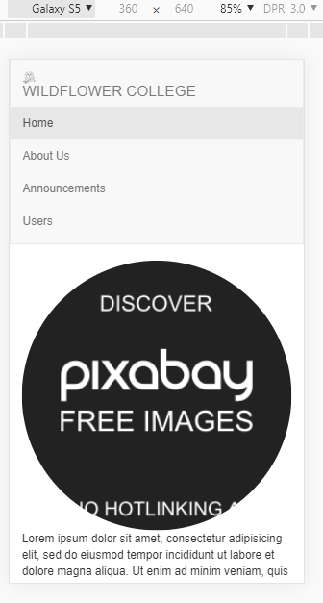

**GALAXY S5 (landscape)**

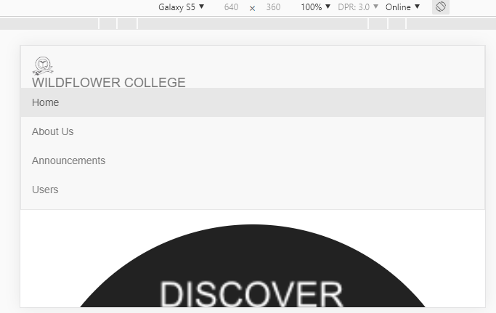

**Iphone6 (portrait)**

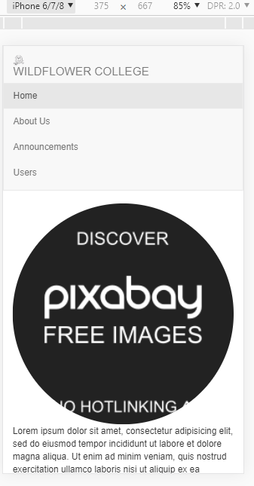

**Iphone6 (landscape)**

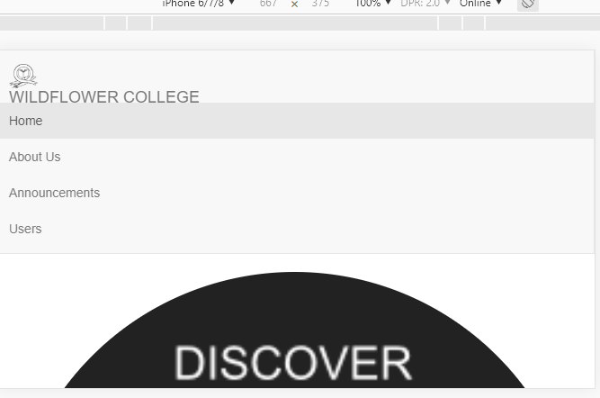

**IPAD PRO**

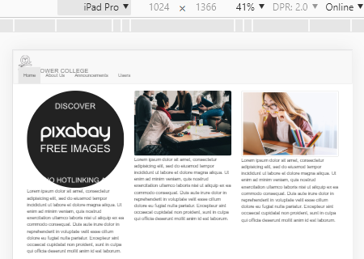

**GIT HUB REPOSITORY**

<https://github.com/shyam13/myProject>